**PRACTICAL JOURNAL**

in

**Advanced Artificial Intelligence**

**&**

**Machine Learning**

Submitted to

**Laxman Devram Sonawane College, Kalyan (W) 421301**

*in partial fulfillment for the award of the degree of*

**Master of Science in Information Technology**

(Affiliated to Mumbai University)

*Submitted by*

**Vrushabh Ravindra pawar**

Under the guidance of

**Mrs. Sabina Ansari ( Advanced Artificial Intelligence)**

**&**

**Dr. Priyanka Pawar ( Machine Learning )**

Department of Information Technology

Kalyan, Maharashtra

Academic Year 2024-25

**PRACTICAL JOURNAL**

in

**Advance Artificial Intelligence**

Submitted to

**Laxman Devram Sonawane College, Kalyan (W) 421301**

in partial fulfilment for the award of the degree of

 **Master of Science in Information Technology**

(Affiliated to Mumbai University)

*Submitted by*

**Vrushabh Ravindra Pawar**

Under the guidance of

**Mrs. Sabina Ansari**

Department of Information Technology

Kalyan, Maharashtra

Academic Year 2024-25



The Kalyan Wholesale Merchants Education Society’s

**Laxman Devram Sonawane College,**

**Kalyan (W) 421301**

**Department of Information Technology**

**Masters of Science – Part II**

**Certificate**

This is to certify that **Mr. Vrushabh Ravindra Pawar**, Seat number **1313274** , studying in Masters of Science in Information Technology Part II , Semester II has satisfactorily completed the practical of “**Advanced Artificial Intelligence** ” as prescribed by University of Mumbai, during the academic year 2024-25.

Subject In-charge Coordinator In-charge ExternalExaminer

College Seal

**ADVANCED ARTIFICIAL INTELLIGENCE**

**INDEX**

|  |  |  |
| --- | --- | --- |
| **SR No.** | **Practical** | **Sign** |
| 1 | Implementing advanced deep learning algorithms such as convolutional neural networks (CNNs) or recurrent neural networks (RNNs) using Python libraries like TensorFlow or PyTorch. |  |
| 2 | Building a natural language processing (NLP) model for sentiment analysis or text classification. |  |
| 3 | Creating a chatbot using advanced techniques like transformer models |  |
| 4 | Developing a recommendation system using collaborative filtering or deep learning approaches. |  |
| 5 | Implementing a computer vision project, such as object detection or image segmentation |  |
| 6 | Training a generative adversarial network (GAN) for generating realistic images |  |
| 7 | Applying reinforcement learning algorithms to solve complex decision-making problems. |  |
| 8 | Utilizing transfer learning to improve model performance on limited datasets. |  |
| 9 | Building a deep learning model for time series forecasting or anomaly detection. |  |
| 10 | Implementing a machine learning pipeline for automated feature engineering and model selection. |  |
| 11 | Using advanced optimization techniques like evolutionary algorithms or Bayesian optimization for hyperparameter tuning |  |
| 12 | Deploying a machine learning model in a production environment using containerization and cloud services. |  |
| 13 | Use Python libraries such as GPT-2 or textgenrnn to train generative models on a corpus of text data and generate new text based on the patterns it has learned. |  |
| 14 | Experiment with neural networks like GANs (Generative Adversarial Networks) using Python libraries like TensorFlow or PyTorch to generate new images based on a dataset of images. |  |

**Practical 1**

**Aim :** Implementing advanced deep learning algorithms such as convolutional neural networks (CNNs) or recurrent neural networks (RNNs) using Python libraries like TensorFlow or PyTorch

**Code :**

import tensorflow as tf

from tensorflow.keras import layers, models

import matplotlib.pyplot as plt

**# Load and preprocess the CIFAR-10 dataset**

(x_train, y_train), (x_test, y_test) = tf.keras.datasets.cifar10.load_data()

x_train, x_test = x_train / 255.0, x_test / 255.0  # Normalize pixel values to [0, 1]

**# Build the CNN model**

model = models.Sequential([

    layers.Conv2D(32, (3, 3), activation='relu', input_shape=(32, 32, 3)),

    layers.MaxPooling2D((2, 2)),

    layers.Conv2D(64, (3, 3), activation='relu'),

    layers.MaxPooling2D((2, 2)),

    layers.Conv2D(64, (3, 3), activation='relu'),

    layers.Flatten(),

    layers.Dense(64, activation='relu'),

    layers.Dense(10, activation='softmax')  # 10 classes for CIFAR-10

])

**# Compile the model**

model.compile(optimizer='adam',

              loss='sparse_categorical_crossentropy',

              metrics=['accuracy'])

**# Train the model**

history = model.fit(x_train, y_train, epochs=10, validation_data=(x_test, y_test))

**# Evaluate the model**

test_loss, test_acc = model.evaluate(x_test, y_test, verbose=2)

print(f'\nTest accuracy: {test_acc}')

**# Plot training & validation accuracy values**

plt.plot(history.history['accuracy'], label='Train Accuracy')

plt.plot(history.history['val_accuracy'], label='Validation Accuracy')

plt.title('Model accuracy')

plt.ylabel('Accuracy')

plt.xlabel('Epoch')

plt.legend()

plt.show()

import torch

import torch.nn as nn

import torch.optim as optim

import torchvision

import torchvision.transforms as transforms

import matplotlib.pyplot as plt

**# Define transformations for the training and testing data**

transform = transforms.Compose([

    transforms.ToTensor(),

    transforms.Normalize((0.5, 0.5, 0.5), (0.5, 0.5, 0.5)),

])

**# Load the CIFAR-10 dataset**

trainset = torchvision

**OUTPUT :**

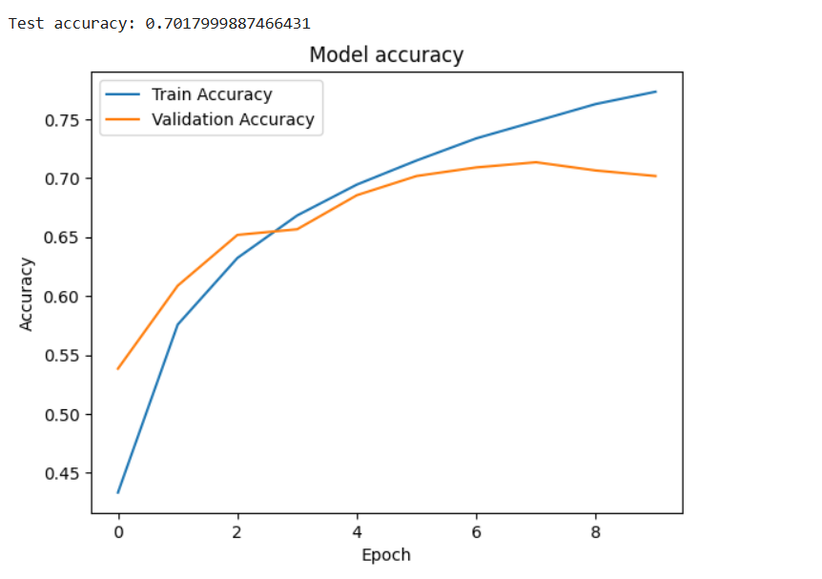

**Practical 2**

**Aim :** Building a natural language processing (NLP) model for sentiment analysis or text classification.

**Code :**

!pip install tensorflow matplotlib

import tensorflow as tf

from tensorflow.keras import layers, models

from tensorflow.keras.preprocessing.text import Tokenizer

from tensorflow.keras.preprocessing.sequence import pad_sequences

from tensorflow.keras.datasets import imdb

import matplotlib.pyplot as plt

**# Step 1: Load the IMDB dataset**

num_words = 10000  # Use the top 10,000 words in the vocabulary

(x_train, y_train), (x_test, y_test) = imdb.load_data(num_words=num_words)

**# Step 2: Explore the dataset**

print(f"Number of training samples: {len(x_train)}")

print(f"Number of test samples: {len(x_test)}")

print(f"Sample review (tokenized): {x_train[0]}")

print(f"Label (0 = negative, 1 = positive): {y_train[0]}")

**# Step 3: Decode a sample review**

word_index = imdb.get_word_index()

reverse_word_index = {value: key for key, value in word_index.items()}

decoded_review = " ".join([reverse_word_index.get(i - 3, "?") for i in x_train[0]])

print(f"Decoded review: {decoded_review}")

**# Step 4: Pad sequences**

maxlen = 200  # Limit each review to 200 words

x_train = pad_sequences(x_train, maxlen=maxlen)

x_test = pad_sequences(x_test, maxlen=maxlen)

**# Step 5: Define the model**

model = models.Sequential([

    layers.Embedding(input_dim=num_words, output_dim=32, input_length=maxlen),

    layers.LSTM(32),  # Use an LSTM layer for capturing sequential dependencies

    layers.Dense(1, activation='sigmoid')  # Output layer for binary classification

])

**# Step 6: Compile the model**

model.compile(optimizer='adam',

              loss='binary_crossentropy',

              metrics=['accuracy'])

**# Step 7: Display the model architecture**

model.summary()

**# Step 8: Train the model**

history = model.fit(x_train, y_train, epochs=5, batch_size=64, validation_split=0.2)

**# Step 9: Evaluate the model**

test_loss, test_acc = model.evaluate(x_test, y_test, verbose=2)

print(f"Test Accuracy: {test_acc}")

**# Step 10: Plot training history**

plt.figure(figsize=(12, 4))

**# Accuracy plot**

plt.subplot(1, 2, 1)

plt.plot(history.history['accuracy'], label='Train Accuracy')

plt.plot(history.history['val_accuracy'], label='Validation Accuracy')

plt.xlabel('Epoch')

plt.ylabel('Accuracy')

plt.legend()

plt.title('Model Accuracy')

**# Loss plot**

plt.subplot(1, 2, 2)

plt.plot(history.history['loss'], label='Train Loss')

plt.plot(history.history['val_loss'], label='Validation Loss')

plt.xlabel('Epoch')

plt.ylabel('Loss')

plt.legend()

plt.title('Model Loss')

plt.show()

**OUTPUT :**



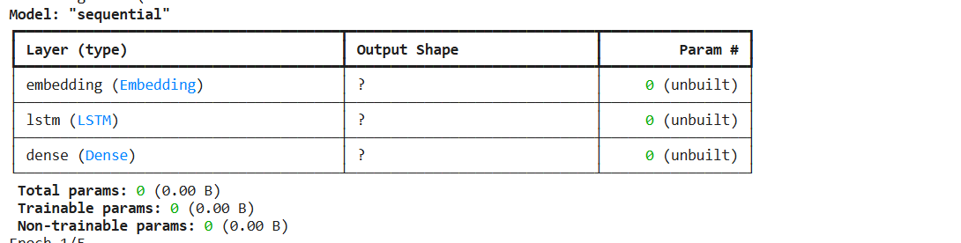

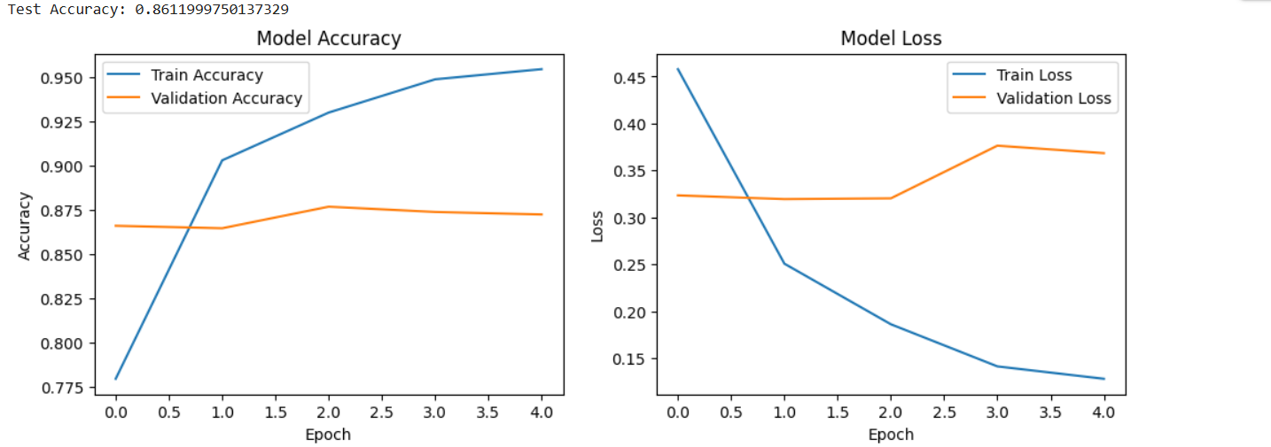

**Practical 3**

**Aim :** Creating a chatbot using advanced techniques like transformer models.

**Code :**

!pip install transformers torch

from transformers import AutoModelForCausalLM, AutoTokenizer

import torch

**# Step 1: Load Pre-trained Model and Tokenizer**

print("Loading the DialoGPT model...")

model_name = "microsoft/DialoGPT-medium"

tokenizer = AutoTokenizer.from_pretrained(model_name)

model = AutoModelForCausalLM.from_pretrained(model_name)

**# Step 2: Initialize Chat History**

chat_history_ids = None

step = 0

**# Step 3: Chat with the User**

print("Chatbot is ready! Type 'exit' to end the chat.\n")

while True:

    # User input

    user_input = input("You: ")

    if user_input.lower() == 'exit':

        print("Chatbot: Goodbye!")

        break

**# Encode the user input and add it to the chat history**

    new_input_ids = tokenizer.encode(user_input + tokenizer.eos_token, return_tensors='pt')

    chat_history_ids = torch.cat([chat_history_ids, new_input_ids], dim=-1) if step > 0 else new_input_ids

**# Generate a response using the model**

    response_ids = model.generate(chat_history_ids, max_length=1000, pad_token_id=tokenizer.eos_token_id)

    response = tokenizer.decode(response_ids[:, chat_history_ids.shape[-1]:][0], skip_special_tokens=True)

**# Display the response**

    print(f"Chatbot: {response}")

    step += 1

**Output :**

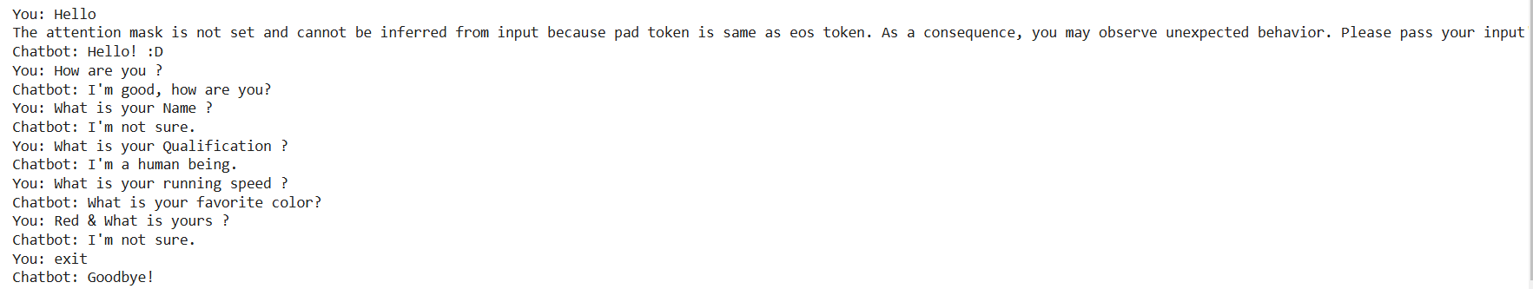

**Practical 4**

**Aim** : Developing a recommendation system using collaborative filtering or deep learning approaches.

**Code :**

**Step 1: Install Required Libraries**

Run the following command to install the necessary libraries:

pip install tensorflow numpy pandas matplotlib

**Step 2: Download the Dataset**

Download the MovieLens 100K dataset from grouplens.org/datasets/movielens. Extract the dataset into a folder.

Alternatively, the code below assumes that the u.data file is in the ml-100k folder.

**Step 3: Python Code for the Recommendation System**

import pandas as pd

import numpy as np

import tensorflow as tf

from sklearn.model_selection import train_test_split

import matplotlib.pyplot as plt

**# Step 1: Load and preprocess the dataset**

file_path = "ml-100k/u.data"

column_names = ['user_id', 'item_id', 'rating', 'timestamp']

data = pd.read_csv(file_path, sep='\t', names=column_names)

**# Normalize user IDs and item IDs to start from 0**

data['user_id'] -= 1

data['item_id'] -= 1

**# Extract the number of users and items**

num_users = data['user_id'].max() + 1

num_items = data['item_id'].max() + 1

print(f"Number of users: {num_users}, Number of items: {num_items}")

**# Step 2: Split data into training and testing**

train_data, test_data = train_test_split(data, test_size=0.2, random_state=42)

**# Step 3: Create TensorFlow datasets**

def create_tf_dataset(df):

users = tf.constant(df['user_id'].values, dtype=tf.int32)

items = tf.constant(df['item_id'].values, dtype=tf.int32)

ratings = tf.constant(df['rating'].values, dtype=tf.float32)

return tf.data.Dataset.from_tensor_slices(((users, items), ratings)).shuffle(1024).batch(32)

train_dataset = create_tf_dataset(train_data)

test_dataset = create_tf_dataset(test_data)

**# Step 4: Define the Recommendation Model**

class MatrixFactorizationModel(tf.keras.Model):

def __init__(self, num_users, num_items, embedding_dim=50):

super().__init__()

self.user_embedding = tf.keras.layers.Embedding(num_users, embedding_dim)

self.item_embedding = tf.keras.layers.Embedding(num_items, embedding_dim)

def call(self, inputs):

user_vector = self.user_embedding(inputs[0])

item_vector = self.item_embedding(inputs[1])

dot_product = tf.reduce_sum(user_vector * item_vector, axis=1)

return dot_product

model = MatrixFactorizationModel(num_users, num_items)

**# Step 5: Compile the model**

model.compile(optimizer=tf.keras.optimizers.Adam(learning_rate=0.01), loss='mse', metrics=['mae'])

**# Step 6: Train the model**

history = model.fit(train_dataset, validation_data=test_dataset, epochs=10)

**# Step 7: Evaluate the model**

test_loss, test_mae = model.evaluate(test_dataset)

print(f"Test Loss: {test_loss:.4f}, Test MAE: {test_mae:.4f}")

**# Step 8: Plot the training history**

plt.figure(figsize=(12, 4))

plt.subplot(1, 2, 1)

plt.plot(history.history['loss'], label='Train Loss')

plt.plot(history.history['val_loss'], label='Validation Loss')

plt.xlabel('Epoch')

plt.ylabel('Loss')

plt.legend()

plt.title('Loss over Epochs')

plt.subplot(1, 2, 2)

plt.plot(history.history['mae'], label='Train MAE')

plt.plot(history.history['val_mae'], label='Validation MAE')

plt.xlabel('Epoch')

plt.ylabel('Mean Absolute Error')

plt.legend()

plt.title('MAE over Epochs')

plt.show()

**# Step 9: Make recommendations**

def recommend(user_id, top_k=5):

user_vector = tf.constant([user_id] * num_items, dtype=tf.int32)

item_vector = tf.constant(list(range(num_items)), dtype=tf.int32)

predictions = model.predict((user_vector, item_vector))

top_items = np.argsort(-predictions)[:top_k]

return top_items

user_id = 0 # Example user

recommended_items = recommend(user_id)

print(f"Recommended items for user {user_id}: {recommended_items}"

**Output :**

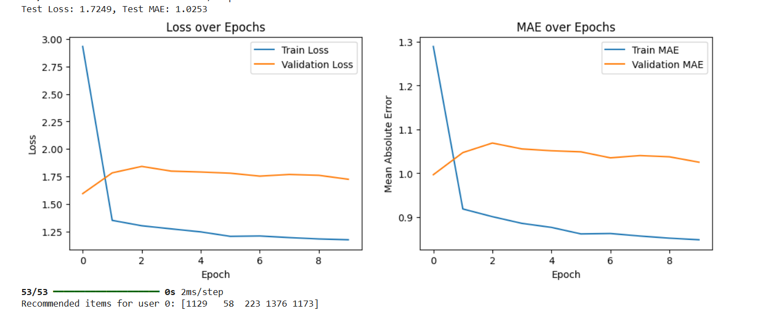

**Practical 5**

**Aim :** Implementing a computer vision project, such as object detection or image segmentation.

**Code :**

!pip install torch torchvision numpy matplotlib opencv-python ultralytics

import cv2

import numpy as np

import matplotlib.pyplot as plt

from ultralytics import YOLO  # YOLOv5 library from ultralytics

**# Step 1: Load the YOLOv5 Model**

print("Loading YOLOv5 model...")

model = YOLO("yolov5s.pt")  # Use the small version of YOLOv5 pre-trained on COCO dataset

**# Step 2: Load an Image for Object Detection**

image_path = "/example.jpg"  # Replace with your image file path

image = cv2.imread(image_path)

image_rgb = cv2.cvtColor(image, cv2.COLOR_BGR2RGB)

**# Step 3: Perform Object Detection**

print("Performing object detection...")

results = model.predict(image_rgb)

**# Step 4: Visualize Results**

annotated_image = results[0].plot()  # Annotated image with bounding boxes and labels

plt.figure(figsize=(10, 10))

plt.imshow(cv2.cvtColor(annotated_image, cv2.COLOR_BGR2RGB))

plt.axis("off")

plt.title("Object Detection Results")

plt.show()

**# Step 5: Save the Annotated Image**

output_path = "output.jpg"

cv2.imwrite(output_path, annotated_image)

print(f"Annotated image saved to: {output_path}")

**# Step 6: Print Detected Objects**

print("Detected objects:")

for box in results[0].boxes.data.tolist():

    x1, y1, x2, y2, conf, cls = box

    print(f"Class: {results[0].names[int(cls)]}, Confidence: {conf:.2f}, Coordinates: ({x1:.2f}, {y1:.2f}), ({x2:.2f}, {y2:.2f})")

**Output :**

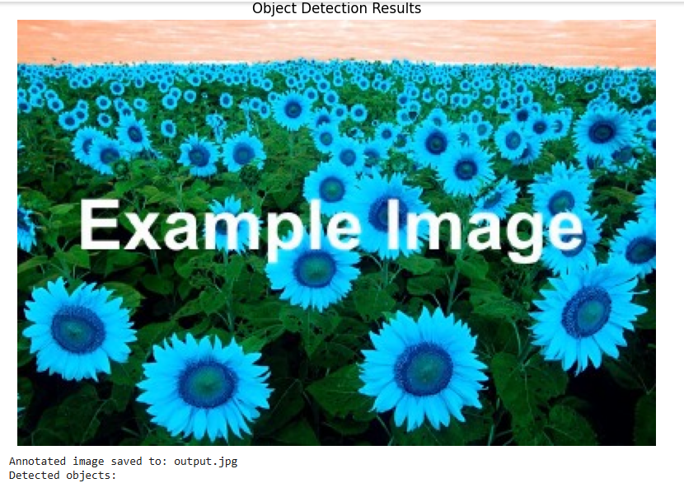

**Practical 6**

**Aim :** Training a generative adversarial network (GAN) for generating realistic images

**Code :**

!pip install torch torchvision matplotlib numpy

import torch

import torch.nn as nn

import torch.optim as optim

from torchvision import datasets, transforms

from torch.utils.data import DataLoader

import matplotlib.pyplot as plt

**# Step 1: Define Generator and Discriminator**

class Generator(nn.Module):

    def __init__(self, noise_dim, img_dim):

        super(Generator, self).__init__()

        self.model = nn.Sequential(

            nn.Linear(noise_dim, 128),

            nn.ReLU(),

            nn.Linear(128, 256),

            nn.ReLU(),

            nn.Linear(256, 512),

            nn.ReLU(),

            nn.Linear(512, img_dim),

            nn.Tanh(),

        )

    def forward(self, x):

        return self.model(x)

class Discriminator(nn.Module):

    def __init__(self, img_dim):

        super(Discriminator, self).__init__()

        self.model = nn.Sequential(

            nn.Linear(img_dim, 512),

            nn.LeakyReLU(0.2),

            nn.Linear(512, 256),

            nn.LeakyReLU(0.2),

            nn.Linear(256, 1),

            nn.Sigmoid(),

        )

    def forward(self, x):

        return self.model(x)

**# Step 2: Define Constants and Hyperparameters**

device = "cuda" if torch.cuda.is_available() else "cpu"

img_size = 28

img_dim = img_size * img_size

noise_dim = 100

batch_size = 64

epochs = 50

lr = 0.0002

**# Step 3: Prepare the MNIST Dataset**

transform = transforms.Compose([transforms.ToTensor(), transforms.Normalize((0.5,), (0.5,))])

dataset = datasets.MNIST(root="data", train=True, transform=transform, download=True)

dataloader = DataLoader(dataset, batch_size=batch_size, shuffle=True)

**# Step 4: Initialize Models, Loss, and Optimizers**

generator = Generator(noise_dim, img_dim).to(device)

discriminator = Discriminator(img_dim).to(device)

criterion = nn.BCELoss()

optimizer_g = optim.Adam(generator.parameters(), lr=lr)

optimizer_d = optim.Adam(discriminator.parameters(), lr=lr)

**# Step 5: Training Loop**

for epoch in range(epochs):

    for real_images, _ in dataloader:

        real_images = real_images.view(-1, img_dim).to(device)

        batch_size = real_images.size(0)

**# Labels for real and fake images**

        real_labels = torch.ones(batch_size, 1).to(device)

        fake_labels = torch.zeros(batch_size, 1).to(device)

**# Train Discriminator**

        noise = torch.randn(batch_size, noise_dim).to(device)

        fake_images = generator(noise)

        real_preds = discriminator(real_images)

        fake_preds = discriminator(fake_images.detach())

        loss_d_real = criterion(real_preds, real_labels)

        loss_d_fake = criterion(fake_preds, fake_labels)

        loss_d = (loss_d_real + loss_d_fake) / 2

        optimizer_d.zero_grad()

        loss_d.backward()

        optimizer_d.step()

**# Train Generator**

        noise = torch.randn(batch_size, noise_dim).to(device)

        fake_images = generator(noise)

        fake_preds = discriminator(fake_images)

        loss_g = criterion(fake_preds, real_labels)

        optimizer_g.zero_grad()

        loss_g.backward()

        optimizer_g.step()

**# Print progress**

    print(f"Epoch [{epoch+1}/{epochs}] | Loss D: {loss_d:.4f} | Loss G: {loss_g:.4f}")

**# Save generated samples every 10 epochs**

    if (epoch + 1) % 10 == 0:

        noise = torch.randn(16, noise_dim).to(device)

        generated_images = generator(noise).view(-1, 1, img_size, img_size).cpu().detach()

        plt.figure(figsize=(8, 8))

        for i in range(16):

            plt.subplot(4, 4, i + 1)

            plt.imshow(generated_images[i].squeeze(), cmap="gray")

            plt.axis("off")

        plt.tight_layout()

        plt.savefig(f"generated_images_epoch_{epoch+1}.png")

        plt.close()

**# Step 6: Save the Generator Model**

torch.save(generator.state_dict(), "gan_generator.pth")

print("Generator model saved as gan_generator.pth")

**Output :**

**Generate after 10 Epoch**

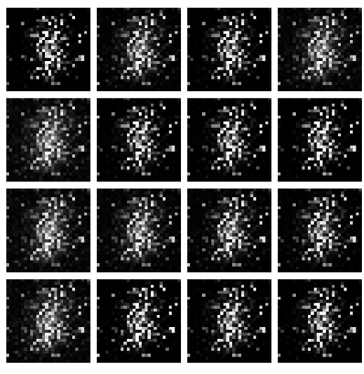

**Generate after 20 Epoch**

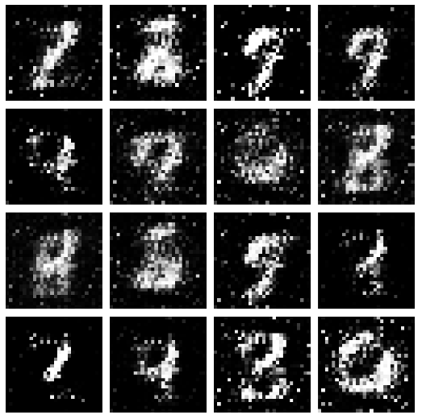

**Generate 30 Epoch**

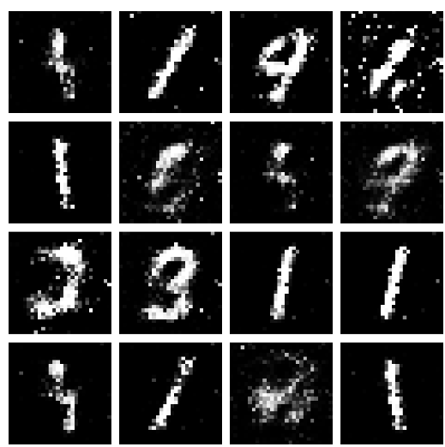

**Generate after 40 Epoch**

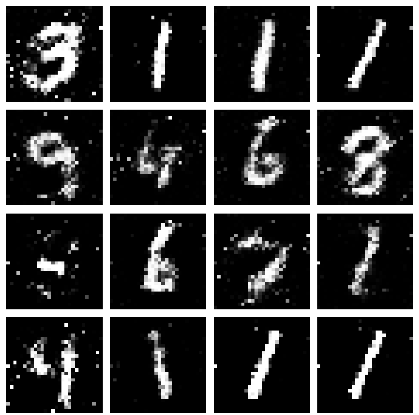

**Generate after 50 Epoch**

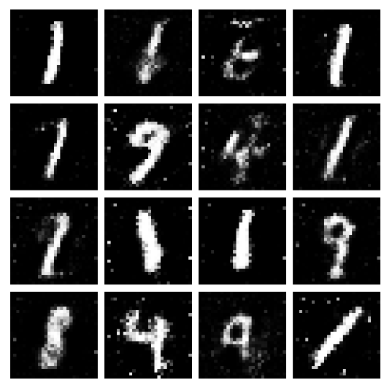

**Practical 7**

**Aim :** Applying reinforcement learning algorithms to solve complex decision-making problems.

**Code :**

**Step 1: Install Required Libraries**

Run the following commands in your terminal to install the necessary libraries:

!pip install numpy gym matplotlib

**Step 2: Python Code for Q-Learning**

Save the following code as q_learning_cartpole.py.

import gym

import numpy as np

import matplotlib.pyplot as plt

**# Step 1: Initialize Environment and Parameters**

env = gym.make("CartPole-v1")

n_actions = env.action_space.n # Number of actions (2: left, right)

n_states = 20 # Discretize continuous state space

episodes = 500 # Number of episodes

learning_rate = 0.1 # Learning rate (alpha)

discount_factor = 0.99 # Discount factor (gamma)

epsilon = 1.0 # Exploration rate

epsilon_decay = 0.995 # Decay factor for epsilon

min_epsilon = 0.01 # Minimum epsilon

**# Step 2: Helper Functions for Discretizing States**

def discretize_state(state, state_bins):

return tuple(np.digitize(state[i], state_bins[i]) for i in range(len(state)))

def create_bins(n_states, env):

state_bins = []

for i in range(env.observation_space.shape[0]):

low, high = env.observation_space.low[i], env.observation_space.high[i]

bins = np.linspace(low, high, n_states - 1)

state_bins.append(bins)

return state_bins

**# Step 3: Initialize Q-Table and State Bins**

state_bins = create_bins(n_states, env)

q_table = np.zeros((n_states,) * len(env.observation_space.shape) + (n_actions,))

**# Step 4: Training Loop**

rewards = []

for episode in range(episodes):

state = discretize_state(env.reset()[0], state_bins)

total_reward = 0

done = False

while not done:

# Epsilon-greedy action selection

if np.random.rand() < epsilon:

action = np.random.choice(n_actions) # Explore

else:

action = np.argmax(q_table[state]) # Exploit

**# Take action and observe results**

next_state_raw, reward, done, _, _ = env.step(action)

next_state = discretize_state(next_state_raw, state_bins)

total_reward += reward

**# Q-Learning update**

q_table[state][action] += learning_rate * (

reward + discount_factor * np.max(q_table[next_state]) - q_table[state][action]

)

state = next_state

**# Decay epsilon**

epsilon = max(min_epsilon, epsilon * epsilon_decay)

rewards.append(total_reward)

print(f"Episode {episode + 1}/{episodes}, Reward: {total_reward}, Epsilon: {epsilon:.3f}")

**# Step 5: Plot Rewards**

plt.plot(rewards)

plt.title("Total Rewards Over Episodes")

plt.xlabel("Episode")

plt.ylabel("Total Reward")

plt.show()

**# Step 6: Save the Q-Table**

np.save("q_table.npy", q_table)

print("Q-Table saved as 'q_table.npy'.")

**# Step 7: Test the Trained Model**

state = discretize_state(env.reset()[0], state_bins)

done = False

total_reward = 0

while not done:

action = np.argmax(q_table[state]) # Use trained Q-Table

next_state_raw, reward, done, _, _ = env.step(action)

state = discretize_state(next_state_raw, state_bins)

total_reward += reward

env.render()

env.close()

print(f"Total reward during test: {total_reward}")

**Practical 8**

**Aim :** Utilizing transfer learning to improve model performance on limited datasets.

**Code :**

**Step 1: Install Required Libraries**

Run the following command to install the necessary libraries:

!pip install torch torchvision matplotlib numpy

**Step 2: Python Code for Transfer Learning**

Save the following code as transfer_learning.py.

import torch

import torch.nn as nn

import torch.optim as optim

from torchvision import datasets, models, transforms

from torch.utils.data import DataLoader

import matplotlib.pyplot as plt

**# Step 1: Set Device and Hyperparameters**

device = torch.device("cuda" if torch.cuda.is_available() else "cpu")

num_classes = 10 # CIFAR-10 has 10 classes

batch_size = 32

epochs = 10

learning_rate = 0.001

**# Step 2: Define Data Transformations**

transform = transforms.Compose([

transforms.Resize((224, 224)), # Resize to match ResNet input size

transforms.ToTensor(),

transforms.Normalize(mean=[0.5, 0.5, 0.5], std=[0.5, 0.5, 0.5]),

])

**# Step 3: Load CIFAR-10 Dataset**

train_dataset = datasets.CIFAR10(root="data", train=True, transform=transform, download=True)

test_dataset = datasets.CIFAR10(root="data", train=False, transform=transform, download=True)

train_loader = DataLoader(train_dataset, batch_size=batch_size, shuffle=True)

test_loader = DataLoader(test_dataset, batch_size=batch_size, shuffle=False)

**# Step 4: Load Pre-trained ResNet18 Model**

model = models.resnet18(pretrained=True)

for param in model.parameters():

param.requires_grad = False # Freeze all layers

**# Replace the final fully connected layer for CIFAR-10**

model.fc = nn.Linear(model.fc.in_features, num_classes)

model = model.to(device)

**# Step 5: Define Loss and Optimizer**

criterion = nn.CrossEntropyLoss()

optimizer = optim.Adam(model.fc.parameters(), lr=learning_rate)

**# Step 6: Training Loop**

def train(model, loader, criterion, optimizer):

model.train()

running_loss = 0.0

correct = 0

total = 0

for inputs, labels in loader:

inputs, labels = inputs.to(device), labels.to(device)

optimizer.zero_grad()

outputs = model(inputs)

loss = criterion(outputs, labels)

loss.backward()

optimizer.step()

running_loss += loss.item()

_, predicted = outputs.max(1)

total += labels.size(0)

correct += predicted.eq(labels).sum().item()

accuracy = 100. * correct / total

return running_loss / len(loader), accuracy

**# Step 7: Testing Loop**

def test(model, loader, criterion):

model.eval()

running_loss = 0.0

correct = 0

total = 0

with torch.no_grad():

for inputs, labels in loader:

inputs, labels = inputs.to(device), labels.to(device)

outputs = model(inputs)

loss = criterion(outputs, labels)

running_loss += loss.item()

_, predicted = outputs.max(1)

total += labels.size(0)

correct += predicted.eq(labels).sum().item()

accuracy = 100. * correct / total

return running_loss / len(loader), accuracy

**# Step 8: Train and Evaluate**

train_losses, test_losses = [], []

train_accuracies, test_accuracies = [], []

for epoch in range(epochs):

train_loss, train_acc = train(model, train_loader, criterion, optimizer)

test_loss, test_acc = test(model, test_loader, criterion)

train_losses.append(train_loss)

test_losses.append(test_loss)

train_accuracies.append(train_acc)

test_accuracies.append(test_acc)

print(f"Epoch {epoch+1}/{epochs}")

print(f"Train Loss: {train_loss:.4f}, Train Accuracy: {train_acc:.2f}%")

print(f"Test Loss: {test_loss:.4f}, Test Accuracy: {test_acc:.2f}%")

**# Step 9: Plot Training and Testing Metrics**

plt.figure(figsize=(12, 5))

plt.subplot(1, 2, 1)

plt.plot(train_losses, label="Train Loss")

plt.plot(test_losses, label="Test Loss")

plt.legend()

plt.title("Loss")

plt.subplot(1, 2, 2)

plt.plot(train_accuracies, label="Train Accuracy")

plt.plot(test_accuracies, label="Test Accuracy")

plt.legend()

plt.title("Accuracy")

plt.show()

**# Step 10: Save the Model**

torch.save(model.state_dict(), "resnet18_cifar10.pth")

print("Model saved as 'resnet18_cifar10.pth'.")

**Practical 9**

**Aim :** Building a deep learning model for time series forecasting or anomaly detection

**Code :**

!pip install numpy pandas matplotlib scikit-learn tensorflow

import numpy as np

import pandas as pd

import matplotlib.pyplot as plt

from sklearn.preprocessing import MinMaxScaler

from tensorflow.keras.models import Sequential

from tensorflow.keras.layers import LSTM, Dense

**# Step 1: Load the Dataset**

url = "https://raw.githubusercontent.com/jbrownlee/Datasets/master/airline-passengers.csv"

data = pd.read_csv(url, usecols=[1], header=0)

data = data.values.astype("float32")  # Ensure the data is float

**# Step 2: Visualize the Data**

plt.plot(data)

plt.title("Airline Passengers Over Time")

plt.xlabel("Time")

plt.ylabel("Passengers")

plt.show()

**# Step 3: Normalize the Data**

scaler = MinMaxScaler(feature_range=(0, 1))

scaled_data = scaler.fit_transform(data)

**# Step 4: Prepare the Data for LSTM**

def create_dataset(dataset, look_back=1):

    X, y = [], []

    for i in range(len(dataset) - look_back):

        X.append(dataset[i:(i + look_back), 0])

        y.append(dataset[i + look_back, 0])

    return np.array(X), np.array(y)

look_back = 12  # Use 12 months (1 year) as input to predict the next value

X, y = create_dataset(scaled_data, look_back)

X = X.reshape((X.shape[0], X.shape[1], 1))  # Reshape for LSTM [samples, time_steps, features]

**# Step 5: Split Data into Training and Testing Sets**

train_size = int(len(X) * 0.8)

X_train, X_test = X[:train_size], X[train_size:]

y_train, y_test = y[:train_size], y[train_size:]

**# Step 6: Build the LSTM Model**

model = Sequential([

    LSTM(50, activation="relu", input_shape=(look_back, 1)),

    Dense(1)

])

model.compile(optimizer="adam", loss="mean_squared_error")

**# Step 7: Train the Model**

history = model.fit(X_train, y_train, epochs=50, batch_size=32, validation_data=(X_test, y_test), verbose=1)

**# Step 8: Evaluate the Model**

loss = model.evaluate(X_test, y_test, verbose=0)

print(f"Test Loss: {loss:.4f}")

**# Step 9: Predict and Inverse Transform**

y_pred = model.predict(X_test)

y_pred = scaler.inverse_transform(y_pred)

y_test_actual = scaler.inverse_transform(y_test.reshape(-1, 1))

**# Step 10: Plot Actual vs Predicted**

plt.figure(figsize=(10, 5))

plt.plot(y_test_actual, label="Actual")

plt.plot(y_pred, label="Predicted")

plt.title("Actual vs Predicted Airline Passengers")

plt.xlabel("Time")

plt.ylabel("Passengers")

plt.legend()

plt.show()

**# Step 11: Save the Model**

model.save("lstm_time_series.h5")

print("Model saved as 'lstm_time_series.h5'.")

**Output :**

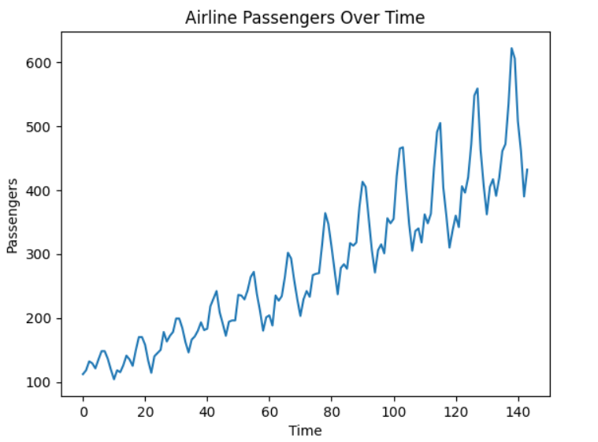

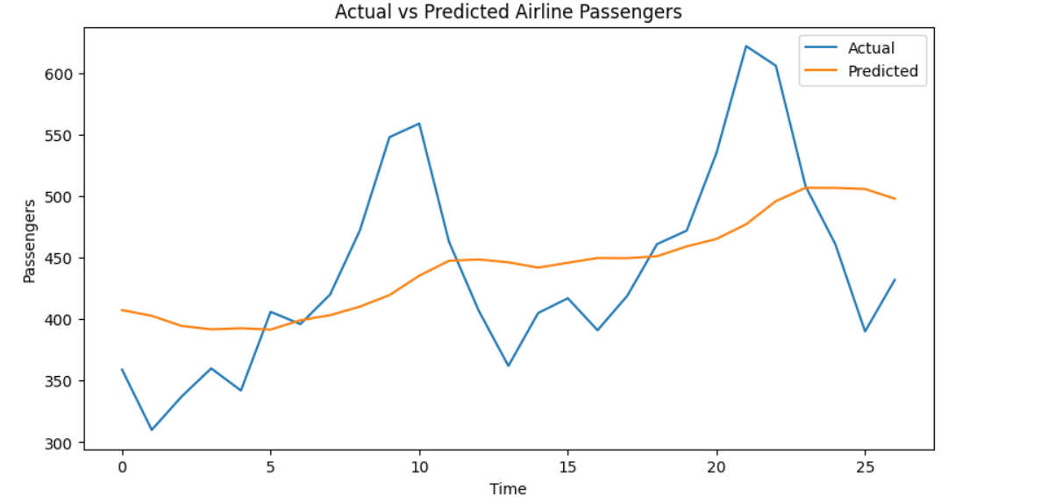

**Practical 10**

**Aim :** Implementing a machine learning pipeline for automated feature engineering and model selection.

**Code :**

**Step 1: Install Required Libraries**

Run the following command to install the required libraries

pip install pandas numpy scikit-learn

**Step 2: Python Code for Machine Learning Pipeline**

Save the following code as ml_pipeline.py.

import pandas as pd

import numpy as np

from sklearn.model_selection import train_test_split, GridSearchCV

from sklearn.pipeline import Pipeline

from sklearn.compose import ColumnTransformer

from sklearn.preprocessing import StandardScaler, OneHotEncoder

from sklearn.feature_selection import SelectKBest, f_classif

from sklearn.ensemble import RandomForestClassifier

from sklearn.svm import SVC

from sklearn.metrics import classification_report, accuracy_score

**# Step 1: Load Dataset**

# Using the Titanic dataset for demonstration

url = "https://raw.githubusercontent.com/datasciencedojo/datasets/master/titanic.csv"

data = pd.read_csv(url)

**# Step 2: Basic Preprocessing**

# Drop unnecessary columns

data = data.drop(["PassengerId", "Name", "Ticket", "Cabin"], axis=1)

**# Handle missing values**

data["Age"].fillna(data["Age"].median(), inplace=True)

data["Embarked"].fillna(data["Embarked"].mode()[0], inplace=True)

**# Separate features and target**

X = data.drop("Survived", axis=1)

y = data["Survived"]

**# Step 3: Split Data into Train and Test Sets**

X_train, X_test, y_train, y_test = train_test_split(X, y, test_size=0.2, random_state=42)

**# Step 4: Define Preprocessing Steps**

# Numerical features: Scale values

numerical_features = ["Age", "Fare"]

numerical_transformer = Pipeline(steps=[

("scaler", StandardScaler())

])

# Categorical features: One-hot encode

categorical_features = ["Sex", "Embarked", "Pclass"]

categorical_transformer = Pipeline(steps=[

("onehot", OneHotEncoder(handle_unknown="ignore"))

])

# Combine preprocessors into a column transformer

preprocessor = ColumnTransformer(

transformers=[

("num", numerical_transformer, numerical_features),

("cat", categorical_transformer, categorical_features)

]

)

**# Step 5: Define Feature Selection and Model Options**

feature_selection = SelectKBest(score_func=f_classif)

# Define candidate models

models = {

"RandomForest": RandomForestClassifier(random_state=42),

"SVC": SVC(probability=True, random_state=42)

}

**# Step 6: Create the Pipeline**

pipeline = Pipeline(steps=[

("preprocessor", preprocessor),

("feature_selection", feature_selection),

("classifier", RandomForestClassifier())

])

**# Step 7: Define Grid Search for Hyperparameter Tuning**

param_grid = {

"feature_selection__k": [5, 6, 7],

"classifier": [models["RandomForest"], models["SVC"]],

"classifier__n_estimators": [100, 200] if "n_estimators" in RandomForestClassifier().get_params() else [None],

"classifier__C": [0.1, 1, 10] if "C" in SVC().get_params() else [None]

}

grid_search = GridSearchCV(pipeline, param_grid, cv=3, scoring="accuracy", verbose=2)

**# Step 8: Train the Model**

grid_search.fit(X_train, y_train)

**# Step 9: Evaluate the Model**

best_model = grid_search.best_estimator_

y_pred = best_model.predict(X_test)

print("Best Parameters:", grid_search.best_params_)

print("Accuracy on Test Set:", accuracy_score(y_test, y_pred))

print("\nClassification Report:\n", classification_report(y_test, y_pred))

**Practical 11**

**Aim :** Using advanced optimization techniques like evolutionary algorithms or Bayesian optimization for hyperparameter tuning.

**Code :**

!pip install numpy pandas scikit-learn scikit-optimize

import numpy as np

import pandas as pd

from sklearn.datasets import load_iris

from sklearn.model_selection import train_test_split, cross_val_score

from sklearn.ensemble import RandomForestClassifier

from skopt import BayesSearchCV

from sklearn.metrics import accuracy_score, classification_report

**# Step 1: Load the Dataset**

data = load_iris()

X, y = data.data, data.target

**# Step 2: Split the Data into Training and Testing Sets**

X_train, X_test, y_train, y_test = train_test_split(X, y, test_size=0.2, random_state=42)

**# Step 3: Define the Model**

model = RandomForestClassifier(random_state=42)

**# Step 4: Define the Search Space for Hyperparameters**

param_space = {

    "n_estimators": (10, 200),          # Number of trees in the forest

    "max_depth": (1, 20),              # Maximum depth of each tree

    "min_samples_split": (2, 10),      # Minimum samples to split a node

    "min_samples_leaf": (1, 10),       # Minimum samples at each leaf

    "max_features": ["sqrt", "log2", None]  # Number of features considered for split

}

**# Step 5: Use Bayesian Optimization for Hyperparameter Tuning**

optimizer = BayesSearchCV(

    estimator=model,

    search_spaces=param_space,

    n_iter=30,  # Number of iterations to search

    cv=3,       # 3-fold cross-validation

    random_state=42,

    n_jobs=-1

)

**# Step 6: Train the Optimized Model**

print("Starting Bayesian Optimization...")

optimizer.fit(X_train, y_train)

**# Step 7: Evaluate the Best Model**

best_model = optimizer.best_estimator_

y_pred = best_model.predict(X_test)

print("\nBest Parameters:", optimizer.best_params_)

print("Accuracy on Test Set:", accuracy_score(y_test, y_pred))

print("\nClassification Report:\n", classification_report(y_test, y_pred))

**# Optional: Save the Best Model**

import joblib

joblib.dump(best_model, "optimized_rf_model.pkl")

print("\nModel saved as 'optimized_rf_model.pkl'.")

**Output :**

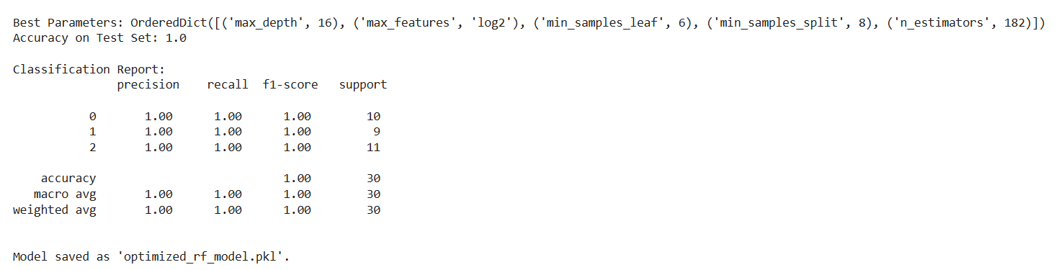

**Practical 12**

**Aim** : Deploying a machine learning model in a production environment using containerization and cloud services

**Code :**

**Step 1: Install Required Libraries**

!pip install scikit-learn pandas fastapi uvicorn

**Step 2: Build the Machine Learning Model**

Save the following Python script as train_model.py. This script trains the model and saves it.

import pandas as pd

from sklearn.datasets import load_iris

from sklearn.ensemble import RandomForestClassifier

import joblib

**# Step 1: Load Dataset**

data = load_iris()

X, y = data.data, data.target

**# Step 2: Train Model**

model = RandomForestClassifier(random_state=42)

model.fit(X, y)

**# Step 3: Save Model**

joblib.dump(model, "iris_model.pkl")

print("Model saved as iris_model.pkl")

Run the script to save the trained model:

bash

Copy code

python train_model.py

**Step 3: Create the API**

Save the following Python script as app.py.

python

Copy code

from fastapi import FastAPI

from pydantic import BaseModel

import joblib

import numpy as np

**# Step 1: Load the trained model**

model = joblib.load("iris_model.pkl")

**# Step 2: Initialize FastAPI**

app = FastAPI()

**# Step 3: Define input schema**

class IrisRequest(BaseModel):

sepal_length: float

sepal_width: float

petal_length: float

petal_width: float

**# Step 4: Define prediction endpoint**

@app.post("/predict/")

def predict(iris: IrisRequest):

features = np.array([[iris.sepal_length, iris.sepal_width, iris.petal_length, iris.petal_width]])

prediction = model.predict(features)

species = ["setosa", "versicolor", "virginica"]

return {"prediction": species[prediction[0]]}

Run the API locally for testing:

bash

Copy code

uvicorn app:app --host 0.0.0.0 --port 8000

Test the API in your browser or with a tool like **Postman**:

* URL: http://127.0.0.1:8000/predict/
* Example Request Body:

json

Copy code

{

"sepal_length": 5.1,

"sepal_width": 3.5,

"petal_length": 1.4,

"petal_width": 0.2

}

**Step 4: Create a Dockerfile**

Save the following as Dockerfile.

dockerfile

Copy code

# Use an official Python runtime as the base image

FROM python:3.9-slim

# Set the working directory in the container

WORKDIR /app

# Copy the current directory contents into the container

COPY . /app

# Install required Python libraries

RUN pip install --no-cache-dir fastapi uvicorn scikit-learn joblib

# Expose the API port

EXPOSE 8000

# Command to run the application

CMD ["uvicorn", "app:app", "--host", "0.0.0.0", "--port", "8000"]

**Step 5: Build and Run the Docker Container**

1. **Build the Docker image**:

bash

Copy code

docker build -t iris-api .

1. **Run the Docker container**:

bash

Copy code

docker run -d -p 8000:8000 iris-api

1. **Test the API**:
   * URL: http://localhost:8000/predict/
   * Use the same JSON request as earlier.

**Step 6: Deploy to a Cloud Service (Optional)**

1. **Prepare the Docker Image**:
   * Tag the image for a container registry (e.g., Docker Hub, AWS ECR, or GCP Artifact Registry):

bash

Copy code

docker tag iris-api <your_dockerhub_username>/iris-api

docker push <your_dockerhub_username>/iris-api

1. **Deploy to AWS ECS (Example)**:
   * Create an ECS cluster.
   * Use the Docker image in a task definition.
   * Deploy the task to the cluster.
2. **Other Options**:
   * Use **AWS Lambda** with **API Gateway**.
   * Deploy on **Google Cloud Run** or **Azure App Service** for managed hosting.

**Step 7: Dataset**

* **Iris Dataset**:
  + Included with sklearn.datasets for demonstration purposes.
  + Automatically loaded in the train_model.py script.

**Practical 13**

**Aim :** Use Python libraries such as GPT-2 or textgenrnn to train generative models on a corpus of text data and generate new text based on the patterns it has learned.

**Code :**

**Step 1: Install Required Libraries**

Run the following commands to install necessary libraries:

!pip install transformers datasets torch

**Step 2: Prepare a Text Dataset**

For demonstration, we'll use the Tiny Shakespeare Corpus available via Hugging Face's datasets library. Alternatively, you can use your own dataset.

**Step 3: Python Code for Training and Generating Text**

Save the following code as train_gpt2.py.

import os

from datasets import load_dataset

from transformers import GPT2LMHeadModel, GPT2Tokenizer, Trainer, TrainingArguments

**# Step 1: Load the Dataset**

print("Loading dataset...")

dataset = load_dataset("tiny_shakespeare")

**# Split into train and test sets**

train_data = dataset["train"]

test_data = dataset["test"]

**# Step 2: Load Pre-trained GPT-2 Tokenizer and Model**

print("Loading GPT-2 tokenizer and model...")

tokenizer = GPT2Tokenizer.from_pretrained("gpt2")

model = GPT2LMHeadModel.from_pretrained("gpt2")

**# Step 3: Tokenize the Dataset**

def tokenize_function(examples):

return tokenizer(examples["text"], truncation=True, padding="max_length", max_length=512)

print("Tokenizing dataset...")

tokenized_train = train_data.map(tokenize_function, batched=True)

tokenized_test = test_data.map(tokenize_function, batched=True)

**# Step 4: Define Training Arguments**

training_args = TrainingArguments(

output_dir="./results",

evaluation_strategy="epoch",

learning_rate=5e-5,

weight_decay=0.01,

per_device_train_batch_size=4,

num_train_epochs=3,

save_total_limit=2,

logging_dir="./logs",

logging_steps=10,

)

**# Step 5: Initialize Trainer**

trainer = Trainer(

model=model,

args=training_args,

train_dataset=tokenized_train,

eval_dataset=tokenized_test,

)

**# Step 6: Train the Model**

print("Starting training...")

trainer.train()

**# Step 7: Save the Fine-Tuned Model**

model.save_pretrained("./fine_tuned_gpt2")

tokenizer.save_pretrained("./fine_tuned_gpt2")

print("Model saved to './fine_tuned_gpt2'.")

**# Step 8: Generate Text Using the Fine-Tuned Model**

print("Generating new text...")

model.eval()

input_text = "To be or not to be, that is the"

inputs = tokenizer.encode(input_text, return_tensors="pt")

outputs = model.generate(inputs, max_length=100, num_return_sequences=1, temperature=0.7)

generated_text = tokenizer.decode(outputs[0], skip_special_tokens=True)

print("\nGenerated Text:\n")

print(generated_text)

**Practical 14**

**Aim :** Experiment with neural networks like GANs (Generative Adversarial Networks) using Python libraries like TensorFlow or PyTorch to generate new images based on a dataset of images.

**Code :**

!pip install torch torchvision matplotlib

import torch

import torch.nn as nn

import torch.optim as optim

from torchvision import datasets, transforms

from torch.utils.data import DataLoader

import matplotlib.pyplot as plt

import os

**# Step 1: Set Device Configuration**

device = torch.device("cuda" if torch.cuda.is_available() else "cpu")

print(f"Using device: {device}")

**# Step 2: Define Generator**

class Generator(nn.Module):

    def __init__(self, noise_dim, img_dim):

        super(Generator, self).__init__()

        self.gen = nn.Sequential(

            nn.Linear(noise_dim, 256),

            nn.ReLU(),

            nn.Linear(256, 512),

            nn.ReLU(),

            nn.Linear(512, img_dim),

            nn.Tanh()

        )

    def forward(self, x):

        return self.gen(x)

**# Step 3: Define Discriminator**

class Discriminator(nn.Module):

    def __init__(self, img_dim):

        super(Discriminator, self).__init__()

        self.disc = nn.Sequential(

            nn.Linear(img_dim, 512),

            nn.LeakyReLU(0.2),

            nn.Linear(512, 256),

            nn.LeakyReLU(0.2),

            nn.Linear(256, 1),

            nn.Sigmoid()

        )

    def forward(self, x):

        return self.disc(x)

**# Step 4: Define Hyperparameters**

noise_dim = 100

img_dim = 28 * 28  # 28x28 images flattened

batch_size = 64

lr = 0.0002

epochs = 50

**# Step 5: Load Dataset**

transform = transforms.Compose([transforms.ToTensor(), transforms.Normalize((0.5,), (0.5,))])

dataset = datasets.MNIST(root="data", train=True, transform=transform, download=True)

dataloader = DataLoader(dataset, batch_size=batch_size, shuffle=True)

**# Step 6: Initialize Models, Optimizers, and Loss Function**

gen = Generator(noise_dim, img_dim).to(device)

disc = Discriminator(img_dim).to(device)

criterion = nn.BCELoss()

opt_gen = optim.Adam(gen.parameters(), lr=lr)

opt_disc = optim.Adam(disc.parameters(), lr=lr)

**# Step 7: Training Loop**

print("Starting Training...")

for epoch in range(epochs):

    for batch_idx, (real, _) in enumerate(dataloader):

        real = real.view(-1, img_dim).to(device)

        batch_size = real.size(0)

        # Train Discriminator

        noise = torch.randn(batch_size, noise_dim).to(device)

        fake = gen(noise)

        disc_real = disc(real).view(-1)

        disc_fake = disc(fake.detach()).view(-1)

        loss_disc = criterion(disc_real, torch.ones_like(disc_real)) + \

                    criterion(disc_fake, torch.zeros_like(disc_fake))

        opt_disc.zero_grad()

        loss_disc.backward()

        opt_disc.step()

        # Train Generator

        output = disc(fake).view(-1)

        loss_gen = criterion(output, torch.ones_like(output))

        opt_gen.zero_grad()

        loss_gen.backward()

        opt_gen.step()

    print(f"Epoch [{epoch+1}/{epochs}] | Loss D: {loss_disc:.4f}, Loss G: {loss_gen:.4f}")

**# Save and Display Sample Images**

    if (epoch + 1) % 10 == 0:

        with torch.no_grad():

            fake_images = gen(torch.randn(16, noise_dim).to(device)).view(-1, 1, 28, 28)

        plt.figure(figsize=(4, 4))

        for i in range(16):

            plt.subplot(4, 4, i+1)

            plt.imshow(fake_images[i][0].cpu(), cmap="gray")

            plt.axis("off")

        plt.tight_layout()

        os.makedirs("generated_images", exist_ok=True)

        plt.savefig(f"generated_images/epoch_{epoch+1}.png")

        plt.close()

print("Training Complete. Generated images are saved in 'generated_images' folder.")

**Output :**

**Generate after 10 Epoch**



**Generate after 20 Epoch**



**Generate 30 Epoch**



**Generate after 40 Epoch**



**Generate after 50 Epoch**

